**А, не знал MODULE 8**

**AIR AND SEA TECHNOLOGY**

“The aeroplane has unveiled for us the true face of the earth.”

*Antoine De Saint-Exupery*

**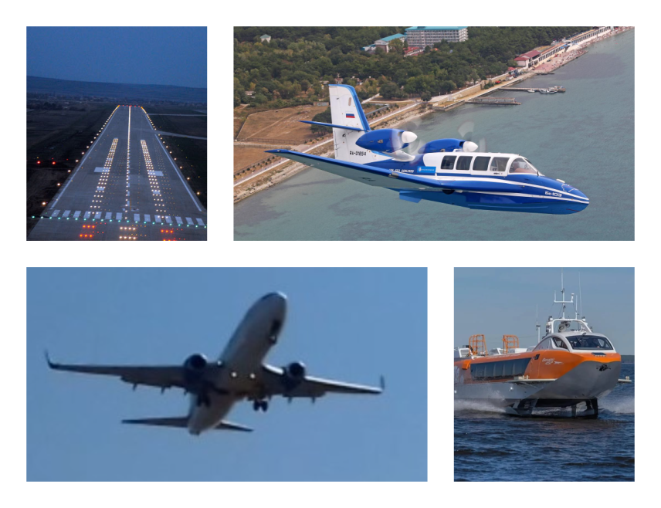**

**Learning points for Module 8:**

• **Reading:**

Text A. **From a Dream of Flight to Modern and Future Air Travel**

Text B. **Discover the Hovercraft**

Text C. **Pioneers in the sky**

• **Vocabulary in context:** word definitions, collocations, synonyms.

• **Grammar**: Unreal Past and The Subjunctive mood.

• **Speaking**: A new birth of closed projects.

**Learning aims:**

- to practise reading and speaking about aircraft and submersibles;

- to learn and practise active vocabulary related to the topic of the module;

-to learn about The Subjunctive mood and to practise speaking about hypothetical situations;

**-**to prepare for Module 8 test.

**Lead-in**

**Forms of transport. *Match the words with the pictures.***

On water

cruise ship / submarine / hovercraft / lifeboat

1. 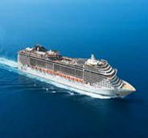 2 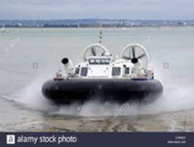 3 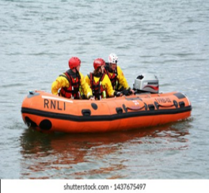 4 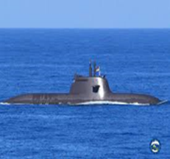

In the sky

dirigible / jet aircraft / helicopter / balloon

1. 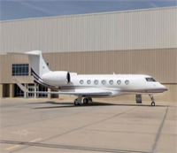 2. 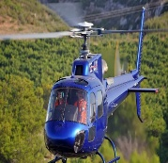 3. 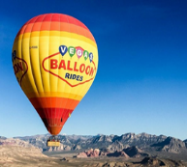 4. 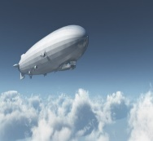

***Discuss in groups.***

1. What other forms of water or air transport do you know?
2. Which of them have you travelled or piloted?
3. What is the fastest means of transport today?
4. What is the safest way to travel, in your opinion?
5. If you were going to travel to a distant destination, would you prefer to go by air or by sea? What type of transport from the pictures above would you choose?

**READING**

**PART 1**

**1. *Discuss the following words* *and try to match them with the definitions.***

ancestor glider marine airframe

milestone propeller tyre(s) cockpit

failure to spin airliner workload

1. a very important event in the development of something;
2. an adjective to describe something connected to the sea, ships or the navy;
3. the body of an aircraft;
4. a piece of equipment consisting of two or more blades that spin around, which makes an aircraft or ship move;
5. a noun meaning not doing something which people expect you to do;
6. the amount of work that a person or machine is expected to do;
7. a large passenger plane (old-fashioned);
8. to turn with a circular movement around a central point, or to make something do this;
9. a thick round band of rubber that fits around the wheel;
10. the area in a plane where the pilot sits;
11. a light plane that flies without an engine;
12. the form in which a modern machine, vehicle, etc. first existed.

**2*. Scan the text and find the following information as quickly as possible.***

1. What is Leonardo da Vinci credited with?
2. When and where did Lomonosov demonstrate his model?
3. When did the first airoplane make its first flight?
4. What should flying of the future be like?

**3*. Skim the text and decide which of the following sentences best answers the question what this text is about. Why?***

* This text is about airplanes.
* The text tells us about the history, present and future of air travel.
* The text tells us about how the dream of mankind to fly like birds was realised when the airplane was invented; how aircraft design continued to adapt and change over time, which ultimately led to the era of mass travel; and, also, how some designers see the future of flying.

**Text 8A**

**From a Dream of Flight to Modern and Future Air Travel**

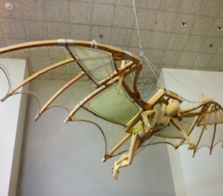(1) The fantasy of flying through the air like birds had been in people’s imagination for hundreds of years before it became a reality. Many early attempts to fly ended in failure and death\*. However, famed Italian inventor Leonardo da Vinci is credited1 with designing early ancestors of the airplane based on the flight of birds*.*

(2) Three centuries had passed before another major milestone in vertical flight appeared. Looking for a way to loft2 meteorological instruments into the air, noted Russian scientist Mikhail Lomonosov designed a model that used two propellers rotating in opposite directions on the same axis3. Lomonosov demonstrated his model powered by a clock spring4 to the Russian Academy of Sciences in 1754. Questions remain whether the device managed to lift itself during the demonstration or whether it was supported by a string5.

(3) The year of 1783 was considered a breakthrough year in aviation: hot air balloons became popular in Europe with the help from the Montgolfier brothers. More significant advances came at the end of the nineteenth century when gliders were developed. Aviation industry received a boost when the Wright brothers developed the theory that the air pressure exerted on different parts of the machine could be altered by making the wings adjustable6 and that that would maintain equilibrium. Starting in 1902, the brothers developed a full sized, power-driven heavier-than-air machine. On December 17, 1903, the first airplane made its maiden7 flight. The airplane was born at just the right time for its intensive development by an industrial society ready with the needed technology. Before the availability of petrol, the Wrights’ invention would have been nothing more than an improvement in gliders. The airplane found the old marine propeller and the new petrol engine ready for application. Pneumatic tires replaced skids8.

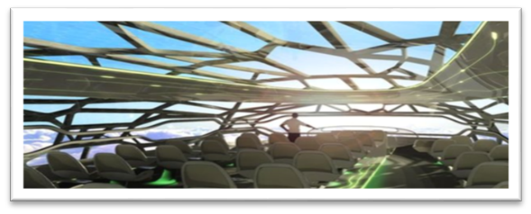(4) The following years were marked by significant progress in the technology of aircraft construction. Aviation developed incredibly fast, with longer and longer flights and larger and larger planes. Aviation shortened distances between places, made it easier for people to travel from country to country and from continent to continent. Very large passenger airliners eventually brought relatively cheap air travel within the reach of millions of people. Today’s airplanes brought to reality a wide range of technological advancements, including the introduction of full fly-by-wire9 flight controls technology, employing advanced materials in its airframes, developing cockpit designs that improve pilot workload and efficiency, environmental control systems, and more. They can take us farther and faster, and move us in greater comfort than ever before.

(5) But what about the future? One of the ideas suggested by aircraft designers is an aircraft with a lace-like10 structure which takes inspiration from the human skeleton, the design which is both strong and relatively lightweight. This means it could, in theory, drastically reduce the fuel costs of flying. The aim would be to 3D print the composite material that would make the structure. Other ideas for the future plane include an upward curve11 on the tail to reflect engine noise upwards and reduce noise pollution. Inside the aircraft, engineers envisage new "zones" to replace the traditional seating, with the seats that are able to harvest energy from those sitting in them as well as change shape to fit the size of passengers. It was also suggested that instead of having small doors into the jet, as is currently the case, the planes of the future would have much wider entrances where people could leave their hand luggage. The bags would then be automatically delivered to their seats. However, design alone would not solve all the industry's problems. Other aviation industry targets are to reduce environmental impact, to enhance efficiency, to ensure safety. Flying in the future must remain safe and affordable for people and safe from an environmental perspective.

*\*you can find out more about the tragic story of Icarus watching this video:* [https://youtu.be/3s2QPQnuaGk](https://youtu.be/3s2QPQnuaGk" \t "_blank)

**Vocabulary notes for text 8A**

1 be credited приписывать кому-либо совершение какого-либо действия

2 to loft отправлять, запускать

3 axis ось

4 spring пружина

5 string струна, веревка

6 adjustable регулируемый, настраиваемый

7 maiden начальный, первый

8 skids полозья

9 fly-by-wire электродистанционная система

10 lace-like похожая на кружево

11 curve кривая, дуга

STUDY NOTE. airplane or aeroplane?

aeroplane - British English, airplane American English noun [countable]

aerocraft is (dated or nonstandard) an aircraft.

aircraft - noun [countable] (plural **aircraft**)

**4*. Read the text in detail and choose the best option to complete the sentences according to the information from the text.***

1. The credit of designing early ancestors of the airplane goes to …

a. Icarus b. Leonardo da Vinci c. Mikhail Lomonosov

2. The device demonstrated by M. Lomonosov to the Russian Academy of Sciences in 1754

a. was supported by a string

b. managed to lift itself

c. either was supported by a string or managed to lift itself

3. The most important breakthrough in aviation definitely was …

a. the appearance of hot air balloons

b. the development of gliders

c. the development of power-driven heavier-than-air machine

4. The first successful airplane flight was made in …

a. 1783 b. 1902 c. 1903

5. Progress in the technology of aircraft construction resulted in …

a. more people travelling over long distances

b. distances actually becoming shorter

c. technological advancements in other forms of transport

6. One of the technological advancements which today’s airplanes brought to reality is

a. high-end computer systems

b. the use of advanced materials

c. considerable reduction in fuel consumption

7. Aircraft engineers are not yet ready to introduce such technologies as

a. flying without pilots b. greater fuel efficiency c. new generation of heat-resistant materials

**5. *Read the text again and fill in the table***

|  |  |  |
| --- | --- | --- |
| The major milestones in the history of air travel | Today’s airplanes | Aircraft of the future ideas |
| * the fantasy of flying like birds * \_\_\_\_\_\_\_\_\_\_\_\_ * \_\_\_\_\_\_\_\_\_\_\_\_ * \_\_\_\_\_\_\_\_\_\_\_\_ * \_\_\_\_\_\_\_\_\_\_\_\_ | * shortened distances between places * \_\_\_\_\_\_\_\_\_\_\_\_ * \_\_\_\_\_\_\_\_\_\_\_\_ * \_\_\_\_\_\_\_\_\_\_\_\_ * \_\_\_\_\_\_\_\_\_\_\_\_ | * lace-like structure * \_\_\_\_\_\_\_\_\_\_\_\_ * \_\_\_\_\_\_\_\_\_\_\_\_ * \_\_\_\_\_\_\_\_\_\_\_\_ * \_\_\_\_\_\_\_\_\_\_\_\_ * \_\_\_\_\_\_\_\_\_\_\_\_ |

**6. *Work in groups of three. In turn, tell your groupmates about the history of air travel, about modern airplanes, and about airplanes of the future. Use Text 8A and/or look for extra information on the Internet to add more ideas.***

**7. *In pairs ask and answer the following questions. Explain your answers or give your own examples. Add two or three more questions to your list. Take notes. Summarise your partner`s answers.***

|  |  |
| --- | --- |
| STUDENT A’s QUESTIONS  1. Did you like reading this article?  2. Are there any facts in the text which surprised you or you find particularly interesting?  3. Have you ever travelled by air? When? Where?  4. Describe one of the flights you or somebody you know have made?  5. What innovations mentioned in the text do you like the most/ find unrealistic?  6. Can you suggest one or two ideas of your own of what the planes of the future should be like? | STUDENT B’s QUESTIONS  1. Did you like reading this article?  2. Are there any facts in the text which surprised you or you find particularly interesting?  3. Have you ever travelled by air? When? Where?  4. Describe one of the flights you or somebody you know have made?  5. What innovations mentioned in the text do you like the most/ find unrealistic?  6. Can you suggest one or two ideas of your own of what the planes of the future should be like? |

**READING**

**PART 2**

**Text 8B**

**Discover the Hovercraft**

|  |  |
| --- | --- |
| **8*. Read the text and write in the missing words.*** §1 A hovercraft, also known as an air-cushion1 vehicle or ACV, is an amphibious craft \_\_\_\_\_\_\_ (1) of travelling over land, water, ice, and other \_\_\_\_\_\_(2). Two jets2 of air are forced downwards underneath the \_\_\_\_\_\_ (3). The cushionof air that is created is held in by a flexible skirt3 that surrounds the base of the vessel. The skirt doesn’t hang vertically, but is drawn in slightly round the bottom, so that air reaching the ground gets pulled back up towards the base of the craft \_\_\_\_\_\_\_ (4) than escaping out under the bottom of the skirt. The \_\_\_\_\_\_\_\_\_ air (5) under the vessel creates invisible rollers4 of air that help to hold it up off the ground. Because the craft is moving through air rather than water, it can go faster than a \_\_\_\_\_\_ (6) boat of similar power.  §2 The first hovercraft was launched in 1955, but it had to wait a few more years to see \_\_\_\_\_\_\_\_ (7). Finally in 1959, the first hovercraft was built and flown across the English Channel. It was an unqualified success, and the hovercraft has since been transformed into the useful and versatile5 vehicle it is today. One of the most outstanding characteristics of the hovercraft is that it can move with equal ease across a land surface or a water surface. It is possible, therefore, for passengers to \_\_\_\_\_\_\_\_ (8) a hovercraft on land, and then be conveyed6 out across water. No special dock \_\_\_\_\_\_\_\_ (9) is needed. It is an ideal form of amphibious transport in wilderness areas. Hovercraft are used for \_\_\_\_\_\_\_ (10), commercial, and military applications to transport, save and protect lives across the world's most \_\_\_\_\_\_\_\_ (11) environments. | *rather*  *surfaces*  *compressed*  *capable*  *vessel*  *conventional*  *board*  *challenging*  *facility*  *the light of the day*  *rescue* |

**Vocabulary notes for text 8B**

1air-cushion воздушная подушка

2 jet сильная струя, поток

3 flexible skirt1 гибкое ограждение воздушной подушки

4 rollers of air *зд.* потоки воздуха

5 versatile разносторонний

6 convey перевозить, переправлять

**9*. Multiple choice quiz. Which option is correct according to the text.***

1. Ahovercraft is …

a. an air-cushion vehicle b. a glider c. a submarine

2. A hovercraft cannot travel …

a. over water b. over land c. over the hills

3. A cushion of … is created by a large fan underneath the craft.

a. steam b. air c. water

4. A skirt surrounding the base of the craft ….

a. allows the air to escape b. prevents too much air from escaping c. protects the craft

5. A hovercraft … a conventional boat of similar power.

a. cannot go faster than b. can go faster than c. goes as fast as

6. The first hovercraft was launched in …

a. 1945 b.1955 c. 1957

7. The hovercraft has since been transformed into a(n) … it is today.

a. useful and versatile vehicle b. effective tool c. sophisticated machine

8. One of the most outstanding characteristics of the hovercraft is that it…

a. is not very noisy b. is very safe c. can move across land or water with equal ease

9. To board the hovercraft passengers …

a. need a special dock facility b. should use a boarding terminal c. don’t need a special dock facility

10. Hovercraft is an ideal form of amphibious transport ….

a. in big cities b. in mountainous areas c. in natural areas

**10. *Retell Text 8B using the words below as clues.***

A hovercraft, an air cushion vehicle, create, surface(s), to hold up, compressed air, rather than, capable of, a vessel, conventional, to launch, to see the light of the day, an unqualified success, useful and versatile, outstanding characteristics, to board a hovercraft, wilderness areas, rescue, applications, challenging environments.

**READING**

**PART 3**

***11. Match the pictures (1-8) with the titles (A-G).***

**1**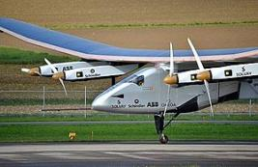 **2** 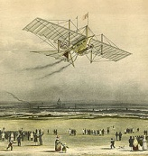 **3** 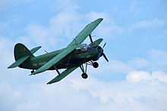 **4** 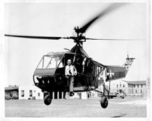 **5** 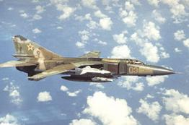

**6** 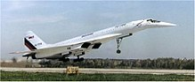 **7** 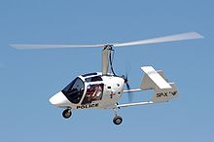 **8** 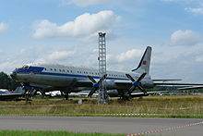

* 1. An Antonov An-2 biplane
  2. An autogyro.
  3. Solar Impulse 2 at the Payerne Air Base in November 2014.
  4. The Tupolev Tu-144 was the first Supersonic aircraft to enter service and the first to leave it
  5. Tu-114 at Monino Museum. (A turboprop-powered long-range airliner)
  6. Sikorsky Helicopter HNS-1 C.G. 39040
  7. The 1842 Aerial Steam Carriage of Henson and Stringfellow
  8. Air fighterA Soviet Air Force MiG-23MLD

**12. *Look at the title. What kind of information do you think the article will give you?***

***Read the article and choose the most suitable heading from the list A-E for each part (1-4) of the article. There is one extra heading which you do not need to use.***

A*.* The race for supersonic flight.

B. Agile like a bird.

C. Modern supersonic fighter.

D. A long way of a dream of flying.

E. Flagman of Soviet aircraft industry.

**Text 8C**

**Pioneers in the Sky**

(1) How could a man make such heavy machines fly? The power of thought of a human being is amazing. Build a model, then you’ll know what the issues are and if it is viable. If Icarus’s mishap is true, the engineers have passed a long way from that. Now we know that to make a heavy machine fly one should know the Law of Aerodynamics. Aerodynamics from Greek (ἀήρ aero-air + δυναμική-dynamics) is the study of motion of air, particularly when affected by a solid object, such as an airplane *wing*. In modern times George Cayley invented the first flying machine that technically demonstrated the chambered *lifting* wing, stabilisers, control surfaces and identified the four *forces* on an aircraft: **propulsion1** (he used a horse to more quickly get into the air) countered by *drag*, aerodynamic *lift* countered by *weight*.

(2)What modern aircraft can do is the most spectacular thing in transportation technologies. The Su-35 with vectored **thrust2** engines and unstable design, probably, is the most maneuverable. The aerobatics of the Su-35 leaves the impression that the aircraft is weightless: it can stop in mid-air and **descend3** in circles, *sailing* like a leaf on the wind. There are plenty of airshow videos showing the Sukhoi do backflips and J turns and what not. It can *hover*, move in any direction and stop on a dime, rotate very quickly through any axis, stop and immediately reverse. Nothing we have seen really comes close to doing what it can do in terms of maneuverability.

(3)The Tu-114 is a long-haul2 aircraft, which is made for the transport of passengers and is equipped with **turboprop4** engines. It was designed in the mid-1950s on the basis of the Tu-95 bomber. The aircraft was in production for four years. It became clear to the designers that the future belongs to *jet**engines* and jet aircraft. Despite this, in the early 1950s it was decided to create a high-speed passenger vehicle using a turbofan power plant. The Tu-114 had no equal in the world *in**terms* of the number of passengers that could be accommodated *on**board*and it had remained the largest passenger plane up till the early 1970s. *Due**to*the fact that the aircraft was a low-wing, the designers *equipped* it with a *fairly* high chassis, which was not found in any aircraft of this class. But this **landing gear5** system also *brought**its**disadvantages*to the aircraft. With the help of this plane, as many as 32 world records were set. They were obtained for the following achievements:

* this was the largest turbofan aircraft at the time that was able to carry passengers on board;
* it was also the fastest passenger *liner* in the world with this type of engine;
* it had the most powerful engines in the world back in its time.

At the moment, there are no operating Tu-114s left in the world. Only three *non***-***operational* versions exist and all the three are used as museum exhibits. During its service life, only two Tu-144s crashed. So, probably, it was also one of the safest aircraft ever.

(4) Although it is Concorde that earned a place in history, the lesser known Tu-144 beat it twice: it had its maiden flight on December 31, 1968, two months before Concorde, and then achieved its first *supersonic flight* in June, 1969, beating the competitor by four months. Both planes were clearly ahead of their time, as civil aviation had barely just transitioned from *props* to *jets*. But their striking similarities have long fuelled spy stories. Although they looked alike and could fly at nearly twice the speed of sound and cut travel time in half, they were rather different planes with many different aspects. The Tu-144 was bigger and faster than the Concorde. Europeans managed to create a liner more suitable for the conditions of market operation. It was more economical, had a longer range and was definitely safer. The Tu-144 had been in passenger service for a year before the type was **withdrawn6** over *safety* concerns, after only 55 flights. Concorde had been twenty-seven years in service and was retired three years after the crash outside Paris on July 25, 2000. So, at this moment there is no supersonic passenger plane *in**service*. Still some companies are working on its development. Will we fly supersonic again?

**13*. Try to guess the meaning of the words in bold in the text (1-6) using the context and the questions below to help you?***

1-What were horses used for?

2-What is the main force to move the aircraft forward? There is a synonym in para 1.

What are the other three forces to make an object fly?

3-Imagine a leaf sailing on the wind. Does it move downwards (see Text 8B )or upwards?

4-Look at the word. The word consists of two words. What are two things which make the aircraft move?

5-Do you know (remember) mechanism of an aircraft which is used for either take-off or landing?

6-Read the whole sentence. Is it about further development of the aircraft? Did they continue using it or stopped?

**14. *Find out the meaning of the words in italics*. C*ircle any other words in text 8C you do not understand, write them down and look them up in the dictionaries.***

**15. *Read the text again and answer the questions.***

1. Why does the author suggest building a model of a plane?

2. What does the author call ‘Icarus’s mishap’?

3. What did George Cayley invent?

4. Why does the Su-35 leave the impression that the aircraft is weightless?

5. In what way was the Tu-144 the best at its time?

6. What were the achievements which allowed the Tu-114 to set 32 records?

7. Why Concorde and the Tu-144 were ahead of their time?

8. Why was the history of their development full of spy stories?

9. In what features were they different?

10. What passenger supersonic planes are in service now?

**16. *Listening and speaking on the topic. Watch one of the videos using the links below. Take notes. Prepare to tell your groupmates about what you have learned. Add your comments. Prepare 3-5 questions to ask your listeners after they have listened to you to check their understanding.***

Visions of future flying: <https://www.youtube.com/watch?v=7oQY0uC52jY>

Meet the dazzling flying machines of the future: <https://youtu.be/RCXGpEmFbOw>

The Aircraft Seats Of Tomorrow: [https://youtu.be/Es89BsdB6a8](https://youtu.be/Es89BsdB6a8" \t "_blank)

The Future of Flying Robots: [https://youtu.be/ge3--1hOm1s](https://youtu.be/ge3--1hOm1s" \t "_blank)

**17*. Watch the video “This plane could cross the Atlantic in 3,5 hours. Why did it fail.” and decide if the sentences below are true or false.***

***[..\..\..\OneDrive\Pictures\This plane could cross the Atlantic in 3,5 hours.mp4](../../../OneDrive/Pictures/This%20%20plane%20could%20cross%20the%20Atlantic%20in%203,5%20hours.mp4)***

1. □ SST, Supersonic transport, is transportation that’s faster than the speed of sound.

2. □ It was designed with computers, and through math and trial and error, they had to innovate constantly to make a supersonic passenger plane possible.

3. □ Concorde passengers were travelling at Mach II, twice the speed of sound

4. □ The Delta Wing, which helped the Concorde get lift at take-off, was called so because of its unique shape, rectangular, like the Greek Delta (Δ).

5. □ Noise levels on take-off were high. But massive **sonic** booms had no comparison.

6. □ It was closed because it caused severe environmental **damage to the ozone** layer.

**C:\Users\matin\AppData\Local\Microsoft\Windows\INetCache\IE\6AMBE5RM\Microsoft_Windows_Write_icon[1].pngWRITING**

**Four Forces of Flight**

**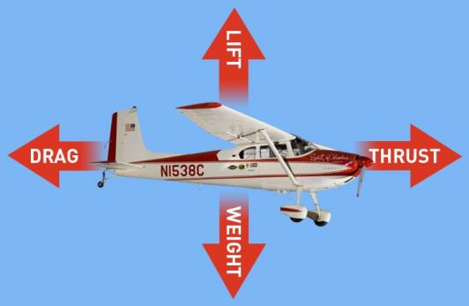1. *Look at the picture and answer the questions. Then complete the table with the words in the box.***

1. Which of the forces are natural and which are artificial?

2. Which of the forces moves the aircraft forward?

3. Which of the forces moves it up?

4. Complete the sentences with the words from the box.

Drag Lift Thrust Weight natural(2) artificial(2)

|  |  |
| --- | --- |
| A.\_\_\_\_\_\_\_\_\_\_\_\_\_\_\_\_\_ | D. \_\_\_\_\_\_\_\_\_\_\_\_\_\_\_\_\_ |
| B.\_\_\_\_\_\_\_\_\_\_\_\_\_\_\_\_\_  Upward force, opposes gravity, supports weight of aircraft | E. \_\_\_\_\_\_\_\_\_\_\_\_\_\_\_\_ Retards forward movement |
| C. \_\_\_\_\_\_\_\_\_\_\_\_\_\_\_\_ Variable with throttle — pulls an aircraft forward | F. \_\_\_\_\_\_\_\_\_\_\_\_\_\_\_\_\_ Gravity - constant in level unaccelerated flight |

**2*. Useful vocabulary. Complete the sentences with the words below***

**backwards forward**  **can’t fly upwards**

1. If Thrust is greater than Drag, the plane moves **\_\_\_\_\_\_\_**.

2. If Drag is greater than Thrust, the plane moves **\_\_\_\_\_\_\_**.

3. If Lift is greater than Weight, the plane moves **\_\_\_\_\_\_\_**.

4. If Weight is greater than Lift, the plane stays on the ground and **\_\_\_\_\_\_\_**.

**3*. Match the synonyms.***

1. move **forward** a. drag

2. move **down b.** thrust

3. move **backwards** c. weight

4. move **upwards d. lift**

**4. *Read the sentence.*** ***Decide if the word counter is closer in meaning with a. or b.***

*Thrust counters the drag.*

*a. cancel, oppose b. advance, encourage*

**5. *Use the phrases to describe how an aircraft takes off.***

Thrust pushes…/…accelerates engine…/…propulsion system... created by engine…/…by increasing propulsion system…/ Thrust counters…/Drag reduces…/…friction between aircraft… /Lift pushes …up against…/…gravity reduces…/ Weight pulls…to…/If Lift is greater than…/…the plane moves…/Special design of the wing…

**VOCABULARY**

**Module 8 Word List**

|  |  |
| --- | --- |
| **Text 8A vocabulary**   1. failure (n) 2. milestone (n) 3. propeller (n) 4. rotate (v) 5. opposite (directions) 6. manage (v) to do smth. 7. support (v, n) 8. receive (v) a boost 9. exert (v) pressure (n) 10. adjustable (adj) 11. marine (adj) 12. incredibly (adv) 13. bring (v) within reach (n) 14. bring (v) to reality (n) 15. workload (n) 16. efficiency (v) 17. take (v) inspiration (n) 18. upward (adj) 19. reflect (v) 20. envisage (v) 21. as well as (prep) 22. luggage (n) 23. deliver (v) 24. target (n) 25. perspective (v) 26. ensure (v) 27. maintain (v) smth. 28. reduce (v) | **Text 8B vocabulary**   1. capable (adj) of 2. surface (n) 3. underneath (prep) 4. vessel (n) 5. rather than doing smth 6. escape (v) 7. unqualified (adj) success 8. See (v) the light of the day 9. board (v) a ship/plane 10. convey (v) 11. facility (n) 12. rescue (v, adj) 13. challenging (adj) environments   **Text 8C vocabulary**   1. viable (adj) 2. propulsion (n) 3. spectacular (adj) 4. descend (v) 5. thrust (n) 6. gear (n) 7. long-haul (adj) 8. accommodate (v) 9. wing (n) 10. striking (adj) 11. suitable (adj) for 12. withdraw (v) 13. be in service 14. retire (v) 15. supersonic (adj) |

**1. *Look at the words below. Give their definitions and try to recall how they were used in text 8A.***

Failure, milestone, propeller, rotate, glider, adjustable, marine, incredibly, workload, efficiency, upward, luggage, perspective, as well as, target.

**2. *Fill in the gaps with the words from Task 1 in the right form. The first letters are given. Translate the sentences into Russian.***

1. A new **m**\_\_\_\_\_\_\_ in aviation industry was reached when Charles Lindberg made his first transatlantic flight which changed the world’s views on possibilities of travel. 2. A few centuries ago people believed that the sun and all the planets **r**\_\_\_\_\_\_\_\_ around the Earth.

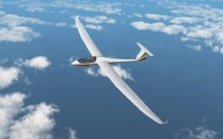3. The first successful heavier-than-air craft were unpowered **g** \_\_\_\_\_\_\_ designed to fly without an engine.

4. The oil spill seriously threatened **m**\_\_\_\_\_\_\_\_ life around the Gulf of Mexico in 2010. 5. Doctors today are having to cope with an ever expanding **w**\_\_\_\_\_\_\_\_ .

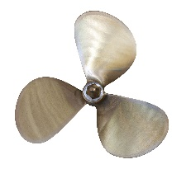6. The sound as **w**\_\_\_\_\_\_\_\_ as the picture quality are best on new TV screens. 7. The loud plane was an open **t**\_\_\_\_\_\_\_\_ for the enemy. 8. The noun phrase the “Icarus paradox” refers to the situation when a business fails after a period of success, where this **f**\_\_\_\_\_\_\_ is brought about by the very elements that led to the initial success. 9. A mechanical device for propelling a boat or aircraft, consisting of a revolving shaft (ось, вал) with two or more blades attached to it is called a **p**\_\_\_\_\_\_\_\_ . 10. With an **u**\_\_\_\_\_\_\_\_\_ trend in inflation we expect prices to rise. 11. If your **l**\_\_\_\_\_\_\_\_\_ is overweight when you check in for a flight, you should pay extra. 12. Sometimes we need to look at life from a different **p**\_\_\_\_\_\_\_\_ .13. Most over the ear headphones are **a**\_\_\_\_\_\_\_\_ , so that they could fit many different head sizes. 14. His car turned over and caught on fire and yet, **i**\_\_\_\_\_\_\_\_ , he wasn’t hurt. 15. The reduction in the number of workers needed to make a car allowed its producers to increase the **e**\_\_\_\_\_\_\_\_ in automotive industry.

**3*. Match the words with numbers (1-10) with the words with letters (a-j) to make up word collocations. Explain the meaning of these expressions and try to recall how they were used in text 8A.***

|  |  |
| --- | --- |
| 1. opposite 2. exert 3. bring something 4. envisage 5. maintain 6. manage 7. bring within 8. receive 9. take 10. ensure | 1. to lift itself 2. reach 3. direction 4. a boost 5. inspiration from 6. pressure 7. new zones 8. safety 9. equilibrium 10. to reality |

**4. *Complete each sentence with the correct word to make up a word collocation from Exercise 3. Translate the sentences into Russian.***

1. With the top Toyota’s hybrid Tundra pickup model fuel economy and car performance will receive a \_\_\_\_\_\_\_\_\_ . 2. The aircraft designers envisage a range of \_\_\_\_\_\_\_\_ for passengers, for example, a gaming zone where passengers will be able to play virtual games. 3. Although many human activities exert \_\_\_\_\_\_\_\_ upon wildlife, the extent of their impact on climate change might be overestimated. 4. On the morning of December 17,1903, the first heavier-than-air craft built by the Wright brothers managed \_\_\_\_\_\_\_\_\_ and soared into the air over a distance of 120 feet. 5. The runway at the Sheremetyevo airport was extended to ensure the \_\_\_\_\_\_\_\_\_\_ of take-off and landing. 6. When the volcano began to erupt, all the drivers were told to drive in the opposite \_\_\_\_\_\_\_\_ from the volcano. 7. It usually takes a lot of time for ideas to be brought to \_\_\_\_\_\_\_\_ . 8. More and more people realise how small our planet is and how important it is to maintain ecological \_\_\_\_\_\_\_\_\_ . 9. Study shows that higher education brings success within \_\_\_\_\_\_\_\_ of not only an individual but also his family. 10. One of the keys to reach your goal is to believe in what you want to see happen in your life and do something to take it \_\_\_\_\_\_\_\_.

**5. *Look at the words below. Try to recall how they were used in text 8B.***

Capable of, surface, underneath, vessel, rather than, to escape, unqualified success, to see the light of the day, to board a ship/plane, to convey, facility, rescue, challenging environments.

**6. *Match the words with the correct definition of the word as it is used in text 8B. Think of your own example sentences with some these words.***

|  |  |
| --- | --- |
| 1. capable of 2. a surface 3. a vessel 4. rather than 5. to escape 6. to see the light of the day 7. to convey 8. a facility 9. rescue 10. challenging 11. beneath 12. to board a plane | 1. situated directly below something 2. an act of saving from danger 3. to become publicly known 4. having the ability to do something 5. a ship or a large boat 6. to go aboard a plane 7. difficult, not easy to deal with 8. something that is built to serve a particular purpose 9. to get away 10. instead of 11. to transfer or deliver 12. the outside part of something |

**7*. Complete the sentences with words given below. Translate the sentences into Russian.***

Facility, the light of the day, board, challenging, capable, rather, rescue, escaped, conveyed, vessel, surface.

1. Lockdown was a \_\_\_\_\_\_\_ time for people in many countries. 2. The fire and other \_\_\_\_\_\_\_\_ services should be provided by professionals. 3. Nuclear research scientists work in a nuclear research \_\_\_\_\_\_\_ . 4. Lots of goods are \_\_\_\_\_\_\_ by ship today. 5. Nobody knows how many great ideas have never seen \_\_\_\_\_\_\_\_. 6. \_\_\_\_\_\_\_ than driving he rode his bike to work. 7. Not many passengers \_\_\_\_\_\_\_\_ from the sinking \_\_\_\_\_\_\_\_\_ . 8. If the \_\_\_\_\_\_\_\_ of the sea is rough our trip will be cancelled. 9. He was one of the best students in his group because he was \_\_\_\_\_\_\_\_ of working hard. 10. After they spent six hours at the airport because of the bad weather, everyone was happy when the passengers were allowed to \_\_\_\_\_\_\_ their plane.

**8*. Find the opposites.* *Match the words in column A with their opposites in column B. Example:*** *‘to evolve’ is the opposite of ‘to decrease, worsen’*

**A.****B.**

|  |  |
| --- | --- |
| 1. failure 2. efficiency 3. opposite direction 4. receive a boost 5. safety 6. reduce 7. upward 8. board a plane 9. underneath 10. capable of | 1. similar direction 2. increase 3. get off a plane 4. incapable/unable 5. success 6. decrease 7. above 8. inefficiency 9. danger 10. downward |

**9*. Rewrite each sentence replacing some of the words by the words in brackets so that it has an opposite meaning to the first sentence. Translate the sentences into Russian.***

1. All their plans ended in failure. (success) 2. The production efficiency is the result of good work. (inefficiency/bad) 3. His car hit a van coming in the opposite direction. (similar) 4. Their production rates received a boost from growing competition. (decrease/because of) 5. You should fasten your seat belts for extra safety. (if you don’t/might/in danger) 6. Some people think that the use of electronic equipment in cars might lead to reducing the number of road accidents. (increase) 7. Unfortunately, prices continue their upward trend. (luckily/downward) 8. One of the ideas is that the planes of the future will have wide entrances which should let passengers to board the plane faster. (get off) 9. The new tunnel goes underneath the city centre. (bridge/above) 10. This robot is capable of understanding spoken commands. (incapable)

**10. *Complete the table.***

***Example:*** *sustainability → to sustain→ sustainable*

|  |  |  |
| --- | --- | --- |
| **Noun** | **verb** | **adjective** |
| 1. safety  2. reality  3. boost  4. reduction  5. facility  6. success  7. direction  8. efficiency  9. support  10. challenge | save  xxxxxxxxxxx | safe |

**11. *Complete the sentences with the correct form of the word in capitals at the end of each sentence.***

1. Scientists are now looking for \_\_\_\_\_\_\_\_ evidence \_\_\_\_\_\_\_\_ the theory of black holes. DIRECTION, SUPPORT 2. This device is very \_\_\_\_\_\_\_\_ at processing complex calculations. EFFICIENCY 3. A lot of ideas sound good in theory but are not useful in the \_\_\_\_\_\_\_ world. REALITY 4. Due to the use of composite materials, the airplanes got more \_\_\_\_\_\_\_\_ and \_\_\_\_\_\_\_. EFFICIENCY , SAFETY 5. There is a pressing need for the \_\_\_\_\_\_\_\_ in the numbers of cars in big cities. REDUCE 6. Holidays without Wi-Fi really \_\_\_\_\_\_\_ young people today. CHALLENGING 7. If you work hard you will finally \_\_\_\_\_\_\_\_ in your quest to become an IT professional. SUCCESS 8.The construction of the new terminal will \_\_\_\_\_\_\_\_ passenger service at the airport. FACILITY

**12. *Work in groups. Choose 5-7 words from Module 8 Word list and prepare a short news story to tell your group using these words. Ask your listeners to note down the words while they listen to your story. Compare your lists.***

***Example****:* At 21 hours and covering almost 17,000 kilometers, **a direct flight** from Sydney to London would be the longest in the world. Travelling this far without a break is an attractive proposition for airlines. The technology is ready to go, with manufacturers saying they’ve built planes **capable** of the journey. So, the industry’s all set to take to the skies for the best part of a day but are pilots and passengers **on board** with the idea? Airlines are keen to **facilitate** passenger **adjusting** to being in the air for so long. But what about the crew? Ultra-**long-haul** flights require four pilots to share the **workload**. Although pilots can refuse to fly if they are tired, the report found most of them believed it would harm their careers to do so. The growing number of longer, **direct flights** is part of a move away from using hub airports where passengers change planes to complete their journeys. As well as saving time for passengers, **direct** flights by more **fuel-efficient jets** are also better for the environment.

**SPEAKING AND DISCUSSION**

**A New Birth of Closed Projects**

**1*. Look at the Key Words. For which of vehicles- air, water or both - do they refer? Look at the photo in the text. How do you think the words might be used in the text?***

***Key words:*** *beach, wave, fly, on the move, flying machine, journey, vessel, cargo, stealth, high-speed, manoeuvre, abandoned, rust*

**2. *Work in pairs. Do you think these statements are true (T) or false (F)?***

1. □ In the photo below you can see an aircraft which can “land” on water.

2. □ The pilot can fly just above the runway for a long time.

3. □ Some laws of aerodynamics are used in cars, aircraft and ships.

4. □ Currently many flying ships - hybrid between airplanes and ships - are in service.

5. □ Some vehicles are able to move not high over the surface of the ground or the water.

**3. *Now read the text and decide if you were right in your answers to Tasks 1 and 2?***

<https://edition.cnn.com/travel/article/caspian-sea-monster-ekranoplan/index.html>

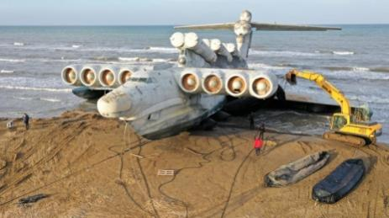Beached on the western shores of the Caspian Sea, it looks like a colossal aquatic beast - a bizarre creation more at home in the deep than above the waves. It certainly doesn't look like something that could ever fly. But fly it did - albeit a long time ago.

After lying dormant for more than three decades, the Caspian Sea Monster has been on the move again. One of the most eye-catching flying machines ever built, it's completing what could be its final journey.

In July 2020 after 14 hours at sea, a flotilla of three tugs1 and two escort vessels maneuvered slowly along the shores of the Caspian Sea to deliver their bulky special cargo to its [destination](https://edition.cnn.com/travel/destinations" \t "_blank), a stretch of coast near Russia's southernmost point.

It's here, next to the ancient city of Derbent, in Russia's republic of Dagestan, that the 380-ton "Lun-class Ekranoplan" has found its new, and most likely definitive, home.

The last of its breed to sail the waters of the Caspian, "Lun" was abandoned after the 1990s collapse of the Soviet Union, condemned to rust away at Kaspiysk naval base, some 100 kilometres up the coast from Derbent.

But before it could *fade into oblivion2*, it's been rescued thanks to plans to make it a tourist attraction right at a time when this unusual travel concept could be poised to make a comeback.

Ground Effect Vehicles, also known as "ekranoplans," are a sort of hybrid between airplanes and ships. They move over water without actually touching it.

In aviation it is when the pilot can then fly just above the runway while the aircraft accelerates in ground effect until a safe climb speed is reached.

In car design, ground effect is a series of effects which have been exploited in automotive aerodynamics to create downforce, particularly in racing cars.

The International Maritime Organisation classifies them as ships, but, in fact, they derive their unique high-speed capabilities from the fact that they skim the surface of the water at a height of between one and five meters (three to 16 feet).

They take advantage of an aerodynamic principle called "ground effect."

This combination of speed and stealth - their proximity to the surface while flying makes them difficult to detect by radar.

*(From CNN)*

*1tug -* буксир

*2fade into oblivion*- кануть в лету

**4*. Read the list of some characteristics of ekranoplan and decide if they are advantages or disadvantages. Complete the table below.***

The ability to land on the water even with strong waves; more economical than airplanes due to the specifics of the flight; used only in good weather conditions (absence of very strong waves); high speed of movement in combination with a large load capacity; the ability to fly over land and ice; low visibility for radars ; necessity to fly at an extremely low altitude; the ability to fly at low altitudes; low maneuverability; specific piloting (requires long-term training); bulky construction; faster than hovercraft (as they reach speeds of 500 kilometers per hour); do not need an airfield.

|  |  |
| --- | --- |
| ***Advantages*** | ***Disadvantages*** |
|  |  |

**5. *Discuss these questions about the future of the technology of ground effect .***

1. What are the advantages of the technology of the ground effect (GEV)?

2. What are its disadvantages?

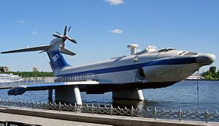3. Do you think the latest developments of modern technologies will give a new birth to the GEV? Read the passage which can give you some thoughts.

*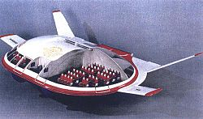In the XXI century, amateur projects of aircraft models-screens were created. One of these aircraft models, created in 2021, is controlled by a computer, and the distance to the surface under the device is measured by a lidar (light detection and ranging technology). A person is not able to control the device due to the excessive complexity of its piloting*

*The ekranoplan that has been moved to Derbent is the only one of its class ever completed and entered service in 1987*.

4. Do you think it is more difficult to pilot a ground effect vehicle then a plane?

5. Why do you think they are safer than the conventional aircraft?

6. What other advantages over planes and ships does it have?

7. What is the Achilles’ heel of ground effect vehicles.

8. Do you think that developers of ground effect vehicles will bring them back to life? If yes, for what purposes?

**Grammar**

**Unreal Uses of Past Forms and The Subjunctive mood**

***1. Read the sentences (1-6). Do the verbs in bold describe situations that are:***

a) true

b) imaginary or unreal

1. I wish I **had** more free time.

2. I **had** more time when I studied at school

3. He talks to us as though we **were** children.

4. We used to play in the park when we **were** children.

5.In Rome we **had** nice accommodation not far from the coast.

5. John **invited** me to the theatre.

6. Suppose I **invited** you to the theatre, would you go?

**STUDY NOTE.** Sometimes we can use *Past Simple**Tense Forms* to describe things which are seen as **unreal or unlikely.**

***Wish/ if only/as if/ as though***

***2. Read and translate the sentences which are examples of using Past Tense Forms to describe unreal or hypothetical situations. Which group of examples describe things***

* which are the imagined or unreal in the present;
* which are the imagined or unreal in the past;

A. 1. If only (I wish) she paid more attention. 2. He speaks English as if he were/was a native speaker. 3. He sounds as though he had a cold.

B. 1. I wish (if only) I hadn`t agreed to take part. 2. If only (I wish) he had listened. 3. If only (I wish) we had seen him yesterday. 4. You are acting as if nothing had happened.

**3*. Look at the sentences in Exercise 2. What verb form follows wish/if only/ as if to talk about unreal (a) present? (b) past?***

***4. Read the rule in the box and choose the correct alternative.***

**Unreal** past is the use of Past Tense Forms to talk about hypothetical (imaginary), unreal or improbable situations. We use:

the **Past Simple** to talk about unreal situations in the *present/in the past*

the **Past Perfect** to talk about unreal situations in the *present/in the past*

***5. Now tell your partner about something that***

***a) you wish were different now:***

*Example: I wish my friend lived closer.*

***b) you wish could happen in the future:***

*Example: If only I could speak Italian.*

***c) you regret about the past;***

*Example: I wish I hadn’t missed the job interview appointment.*

**STUDY NOTE.** **Wish/ If only**

Wish/ if only + **past simple** to express a wish about the **present**.

Wish/ if only + **past perfect** to express a wish about the **past**.

Wish/ if only + **would** to express an impossible wish for a future change or wish to express **annoyance**.

Wish/ if only + could (have) to describe a desire we know is impossible to achieve

We do not use wish + would in the same person. It's not usually used about ourselves,

*~~I wish I would know English.~~*

***6. Study the examples below paying attention to the verbs in bold. Choose the correct alternative.***

1. If we **had** a pool, I would swim every day.

a. They don’t have any swimming pool. b. They had a swimming pool

2. Suppose I **bought** a new car, would you go with me to the sea?

a. He has a new car. b. He doesn’t have a new car.

3. If she **had told** me about this before, I would have booked the tickets.

a. She didn’t tell me. b. She doesn’t tell me.

4. Provided new composite materials were used, overall aircraft weight would be lower.

a. Composite materials were used. b. They don’t use new composite materials.

5. I wish I **had** a cup of coffee right now.

a. She doesn’t have a cup of coffee. b. She has a cup of coffee .

6. My sister wishes she **had taken** that job.

a. She regrets she hasn’t taken that job. b. She doesn’t want that job.

7. He wishes he **weren’t** so bad at maths.

a. He is good at maths. b. He would like to be better at maths.

8. He wishes he **didn’t need** to go to work so early.

a. He goes to work very early. b. He likes to go to work early.

9. I wish that Tim **wouldn't work** late so often.

a. Tim doesn’t want to work less. b. I want Tim to come home not so early.

10. I wish our neighbours **would** be quiet!

a. They are not quiet. b. I don't mind the noise.

***7. Read the sentences and put the verbs into correct tense. In some sentences use the Passive Voice.***

1. I wish I \_\_\_\_\_ (have) opportunity to improve my knowledge and skills.

2. I wish I\_\_\_\_\_ (not take) a course on Latin. I didn’t think it’s so tiring.

3. We wish we \_\_\_\_\_ (get) accommodation not far from the coast.

4. He talks to us as though he\_\_\_\_\_ (investigate) some criminal case.

5. She wishes she \_\_\_\_\_ (not start) to prepare for higher degree, she changed her mind.

6. I wish I \_\_\_\_\_ (offer) a wider range of options.

7. Suppose she \_\_\_\_\_ (have) the ability to explain things more concisely, would you trust her with organizing the case?

8. Peter touted his car as if it \_\_\_\_\_ (have) the most advanced engine.

9. I wish our tasks \_\_\_\_\_ (assess) once a month. But it wasn’t accepted in my institution.

10. They give us so many assignments to complete. I wish they (not do) that.

**It’s high/ about time…/What if…/suppose/supposing…/would rather (sooner)**

**STUDY NOTE.** There are some other expressions with which we can also use Past Tense Forms to refer to **unreal** past, present or future: **It’s high/about time…What if…/ suppose/supposing…would rather/sooner.** For example:

It’s high/ about time you **started** revising for the exams.

What if /suppose/supposing you **started** revising for the exams now?

I would rather/sooner you **started** revising for the exams.

**Compare:**

If he **started** revising for the exams now, he wouldn’t fail.

I wish (If only) he **started** revising for the exams.

He sounds as if (as though) he **started** revising for the exams.

**8*. Read the examples of different types of sentences with It’s high time/It’s about time below and answer the questions.***

Does *It’s high time/It’s about time* mean something that should be happening now, but it isn’t? Or does it mean that something is happening on time? What verb form follows *It’s high time/It’s about time?*

1. It’s time you started doing your homework. 2. It’s high time you didn't act so impulsively. 3. It's high time we left for the airport. We are going to be late. 4. It's time to leave for the airport. So far, we have a good chance to be on time.5. It’s about time you phoned to your parents.

**Study note.** We use Past Simple after It’s high/about time …to say that something is not happening and it should be. We use It’s time to + infinitive …when we don’t mean to say that something is not happening.

**9*. Put the verbs in brackets into the correct forms.***

1. It’s high time we \_\_\_\_\_(leave). We are going to miss the train.

2. Ok, clearly it's time \_\_\_\_\_(talk).

3. Supposing you\_\_\_\_\_ (look) at that job ad, where would you be working now?

4. What if they \_\_\_\_\_ (accept) only cash? We would have to look for an ATM.

5. I’d rather you \_\_\_\_\_ (study) more. Your exam is coming.

6. I’ d rather you \_\_\_\_\_ (repair) your computer. You wouldn’t have asked me to lend you mine.

7. I love your house as if it \_\_\_\_\_ (be) my own.

8. He talks about Pete as though he \_\_\_\_\_ (be) his best friend.

***10. Complete these sentences with the correct form of the verb in brackets.***

1. If I (be) you, I would phone him. 2. If only I (revise) for my exam yesterday! 3. I wish I (not choose) this theme for my presentation. 4. If I (know) about the lecture, I would have definitely gone. 5. I wish I (be) taller so I could be in the basketball team. 6. If only children (read) more nowadays. 7. If only people (use) less cars when they can use public transport. 8. I wish I (know) the answer, but I don’t. 9. If they (try) to save water, the reservoir wouldn’t have dried. 10. I wish you (be) quiet. Your talking irritates me.

***11. Complete the sentences with the words below. Put them into correct form.***

can know do act do change try buy tell get

1. I wish I \_\_\_\_\_ afford to buy a new washing machine.

2. I wish I \_\_\_\_\_what is wrong with my computer.

3. It's time we \_\_\_\_\_something to stop water pollution in the river.

4. He always talks as though he \_\_\_\_\_on the stage.

5. He talks as if he \_\_\_\_\_all the work himself, but I know Tim helped him.

6. It's high time you \_\_\_\_\_your job.

7. If only they \_\_\_\_\_a bit harder, they would have won.

8. It’s time we \_\_\_\_\_a new car.

9. I wish I \_\_\_\_\_anyone about this. I really regret.

10. If only he \_\_\_\_\_ill. He wouldn’t have retired.

***12. Rewrite the sentences using I wish + past simple, past perfect or would depending on the situation. Translate the sentences into Russian.***

1 I haven't got a flat of my own. I would very much like to have one.

*I wish I had a flat of my own.*

2. I didn’t walk in the park yesterday. I regret it now.

\_\_\_\_\_\_\_\_\_\_\_\_\_\_\_\_\_\_\_\_\_\_\_\_\_\_\_\_\_\_\_\_\_\_\_\_\_\_\_\_\_\_\_\_\_\_\_\_\_\_\_

3. We don’t speak foreign languages. I would like us to.

\_\_\_\_\_\_\_\_\_\_\_\_\_\_\_\_\_\_\_\_\_\_\_\_\_\_\_\_\_\_\_\_\_\_\_\_\_\_\_\_\_\_\_\_\_\_\_\_\_\_\_

4. I didn't take his invitation. I regret it now.

\_\_\_\_\_\_\_\_\_\_\_\_\_\_\_\_\_\_\_\_\_\_\_\_\_\_\_\_\_\_\_\_\_\_\_\_\_\_\_\_\_\_\_\_\_\_\_\_\_\_\_

5. They won’t stop making a noise. I would like him to

\_\_\_\_\_\_\_\_\_\_\_\_\_\_\_\_\_\_\_\_\_\_\_\_\_\_\_\_\_\_\_\_\_\_\_\_\_\_\_\_\_\_\_\_\_\_\_\_\_\_\_

6. I didn’t tell the truth. I regret it now.

\_\_\_\_\_\_\_\_\_\_\_\_\_\_\_\_\_\_\_\_\_\_\_\_\_\_\_\_\_\_\_\_\_\_\_\_\_\_\_\_\_\_\_\_\_\_\_\_\_\_\_

7 You didn’t answer my letter. I’ m very sorry you didn’t.

\_\_\_\_\_\_\_\_\_\_\_\_\_\_\_\_\_\_\_\_\_\_\_\_\_\_\_\_\_\_\_\_\_\_\_\_\_\_\_\_\_\_\_\_\_\_\_\_\_\_\_

8. I’d like you to stop interrupting me.

\_\_\_\_\_\_\_\_\_\_\_\_\_\_\_\_\_\_\_\_\_\_\_\_\_\_\_\_\_\_\_\_\_\_\_\_\_\_\_\_\_\_\_\_\_\_\_\_\_\_\_

**Uses of Would/TheSubjunctive Mood**

***13. In which group of sentences (A-D) do the verbs in bold describe situations that are:***

1. hypothetical Present or Past with *could, might, would;*
2. a polite command, request or wish;
3. are used in a very formal context in that-clause with such verbs as *demand, insist, recommend, suggest, order, etc.*
4. are used in a very formal context in that-clause after nouns or adjectives expressing a demand, a recommendation, a desire, importance, necessity etc.

A. 1. Would you like to listen to the audio again? 2. I’d like to tell you about the advantages of air travel. 3. Would you mind answering a few questions? 4. I‘d prefer to do an online course in English rather than a face-to-face. 5. Would you help me with filling out this form?

B. 1. We would go out later, wouldn`t we? 2. He wouldn`t do that. 3. I would never run a marathon now. 4. I would have appreciated some help. 5. The keys would be in one of those drawers. 6. I would never consider changing career.

C. 1. We insist that a meeting be held (or should be held) as soon as possible. 2. The board recommends that the accounts be (should be) checked. 3. I suggested that we should wait for him. 4. She insists that you should see a doctor. 5. I suggest that the meeting be postponed. 6. I demand that I be allowed to call my lawyer. 7. It is required that you (should) do what you were told to do.

D. 1. Was it necessary that my uncle be informed? 2. It is necessary that the work should be done today. 3. It`s important that everybody should listen very carefully. 4. It`s strange that he should be late. 5. It is important that everything should be ready by six o'clock. 6. It is advisable that she should stay in the hospital. 7. It is essential that safety remain (should remain) top priority.

**Uses of *would***

* polite request: *Would you help me get the files?*
* the hypothetical Present or Past : *We would never dream of having our own plane.*
* strong desire for something: *I wish he would make more of an effort!*

***14. Correct the mistakes in the sentences.***

1. Would you helped me drive the car to the service station? 2. I wish she will be here immediately! 3. I’d love to know what would happened! 4. Would you to give me a lift after work today? 5. She wishes I won’t jump with a parachute! 6 I’d love to know whether they still would taken part in the game!

**STUDY NOTE. Present Subjunctive Mood** form is the same as bare infinitive. It is used when the sentence shows a degree of urgency or strong emotion. It is rather formal. It can be used after certain verbs, such as *demand, insist, propose, recommend, suggest, beg, order, request, etc.*

* *Example: Regulations require (that) the witness be interviewed without delay. The assistant insisted (that) Ann arrive at work by 8:00. The fireman demanded (that) they leave the burning building immediately. My aunt and uncle insisted (that) we not come to visit them today.*

**The** **Subjunctive mood** is more common in American English than in British. In British English it is more common to say: I suggest that he **should** be here.

***15. Put the verbs in brackets into the correct forms.***

1. He ordered that all lights (extinguish). 2. The doctor recommends (that) Uncle John (hospitalise). 3. I propose (that) we (ask) Mom and Dad. 4. It is necessary that my sister (get) medical treatment. 5. It's important she (understand) your opinion.

**STUDY NOTE.** The subjunctive mood is also used after adjectives of advice, necessity, and urgency, such as *advisable, essential, eager, crucial, necessary, important, desirable, determined, preferable, unnecessary, urgent, vital, etc.*

**It is/was + adjective + that + bare inf**

*It is advisable (that) independent agency be put in charge of this survey.*

*It is mandatory (that) no one enter the lab without a permit.*

*It is urgent (that) he complete the form at once*.

These adjectives can also be followed by to-infinitive. Compare*: It's essential to communicate. (to-infinitive) It's essential that she communicate with her parents.(subjunctive)*

**16. *Correct mistakes in the sentences. Some sentences are correct.***

1. It is essential that elderly people were treated with dignity. 2. It's important that she to understand her options. 3. It’s advisable that my brothers and sisters are present. 4. It is desirable that she should be here. 5. The community suggested the transport in the region be improved.

**Summary of Constructions with Hypothetical Meaning**

|  |  |
| --- | --- |
| Second conditional  Third conditional  Mixed (second/third) conditional  Mixed (third/second) conditional  Subjunctive (the same as the infinitive without to)  It’s (high/about) time  What if/suppose/supposing  Would rather/would sooner  As if/as though  Wish/if only+ past simple  Wish/if only+ past perfect  Wish /If only+ would  Wish / if only+ could (have) | * If she paid more attention in class, she would understand Physics. * If I were you, I would walk in this park every day. * If they had repaired electrical wires, there would have been a fire. * If we had had more time, we could have visited the exhibition. * If this destination were more popular, we would have swum side by side with a lot of people. * If Hertz hadn't discovered magnetic field, we wouldn’t use our appliances. * At yesterday's lecture the professor insisted we write down all the quotes. * It’s about time you raised my salary. * What if/suppose/supposing the volcano erupted? * I Would rather/would sooner you tried as hard as you can. * He insists on our attending the lecture as if he were a teacher. * I wish/if only you were here. * I wish/if only you had passed your driving test. * I wish/if only they would stop arguing. * I wish/if only I could speak German. |

**17*. Make up sentences using both an adjective and the correct form of a verb from the box. Some sentences may be in the passive voice.***

What do seniors need to enjoy their golden years?

advisable/make crucial/necessary essential/treat important/stay vital/visit

**18. *Use your own ideas to complete the sentences.***

1. If she \_\_\_\_\_ , she would \_\_\_\_\_ .
2. If I were you, I would \_\_\_\_\_ .
3. If they had \_\_\_\_\_ , there would(n’t) have \_\_\_\_\_.
4. If we had had \_\_\_\_\_ more \_\_\_\_\_, we could have \_\_\_\_\_.
5. If \_\_\_\_\_ were more \_\_\_\_\_, we would have \_\_\_\_\_ .
6. If \_\_\_\_\_ hadn't discovered (invented) \_\_\_\_\_, we would(n’t) \_\_\_\_\_.
7. It’s about time you \_\_\_\_\_ .
8. What if/suppose/supposing \_\_\_\_\_ ?
9. I would rather/would sooner you \_\_\_\_\_
10. I wish/if only you were \_\_\_\_\_
11. I wish/if only you had \_\_\_\_\_
12. I wish/if only they would \_\_\_\_\_
13. I wish/if only I could \_\_\_\_\_ .

**CHECK YOURSELF**

***1. The History of Aviation Quiz.***

1. What engine was on the first plane of the Wright brothers:

a. Diesel b. Gasoline c. Electric

2. In what century did the Montgolfier brothers lift the first balloon into the air:

a. 19th b. 18th c. 17th

3. Who is called "father of Russian aviation"?

a. Sikorsky b. N. Zhukovsky c. K. Tsiolkovsky

4. Which military figure and inventor built an airplane in 1883 at his own expense:

a. Mozhaisky b. Wrangel c. Spassky

5. What does "aviation" mean in Latin:

a. To fly b. Flight c. Bird

6. What type of engine was not used by the English inventor of the first half of the XIX century, Sir George Cayley, in his aircraft:

a. External combustion b. Steam c. Internal combustion

7. What is Igor Sikorsky best known for developing?

a. hover. b. helicopter c. glider

8. What is the world's largest passenger plane?

a. Airbus А380 b. Воеing 747 c. Tu-144

9. What is the most cargo-carrying aircraft in the world?

a. А-350 b. An-225 “Mriya” c. An-124 “Ruslan”

10. A. Tupolev designed or oversaw the design of more than \_\_\_ types of civilian and military aircraft in the Soviet Union.

a. 50 b. 100 c.30

11. The sonic barrier is the large increase in aerodynamic drag and other undesirable effects experienced by an aircraft when it approaches

a. the speed of sound. b. subsonic speed c. Mach1

12. What happens if lightning strikes the plane:

a. The plane will shake, as in severe turbulence

b. There may be minor damage to the skin that does not pose a threat

c. People on board may be electrocuted

13. In honour of which hero is the Russian passenger plane named, developed under the guidance of aircraft designer I. I. Sikorsky:

a. Ilya Muromets b. Alyosha Popovich c. . Dobrynya Nikitich

14. How often do planes take off and land in the world?

a. Every 5 seconds b. Every 2 seconds c. Every 10 seconds

15. What kind of aircraft does not happen in terms of flight speed?

a. Supersonic b. Both options are correct c. Gigosonic

**VOCABULARY**

**2*. Explain the meaning of the following words in English.***

***Example:*** *petrol → liquid obtained from oil used as a fuel for cars and other vehicles (US gas).*

A failure, an ancestor, a propeller, efficiency, a glider, a surface, a vessel, a facility, a target, a perspective, challenging environments, to rotate, adjustable, incredibly, marine, workload, as well as, capable of, to escape, to convey, rescue, beneath.

***3.* *Guess the word using its definition.***

***Example:*** *a very important event in the development of something → a* ***milestone.***

1. the body of an aircraft;
2. the amount of work that a person or machine is expected to do;
3. to turn with a circular movement around a central point;
4. the area in a plane where the pilot sits;
5. the outside part of something;
6. difficult, not easy to deal with;
7. to go aboard a plane;
8. having the ability to do something;
9. an act of saving from danger;
10. to become publicly known;
11. situated directly below something
12. a ship or a large boat
13. something that is built to serve a particular purpose
14. a verb meaning *to get away*
15. a synonym phrase to *instead of*
16. a verb meaning *to* *transfer or deliver*
17. a light plane that flies without an engine;
18. an adjective used to describe something connected to the sea, ships or the navy;
19. to turn with a circular movement around a central point;
20. the form in which a modern machine or vehicle first existed.

**4.\*. *Rewrite each sentence below replacing the underlined word by one of the words given below so that the new sentence will have the same meaning as the first one. Translate the sentences into Russian if necessary.***

***Example:*** *The difficult driving conditions led to several accidents. (cause)*

*The difficult driving conditions caused several accidents.*

To envisage, manage, ensure safety, bring something to reality, to inspire, go upward to, to exert, to maintain, efficiency, opposite, an ancestor, receive a boost, a failure, bring within reach, board a plane.

1. The crash happened because the car in front of the driver suddenly turned around and went in a different direction. 2. The governments must put pressure on manufacturing companies to reduce harmful emissions. 3. If you really want to achieve your goals, you should be determined and focus on what you want to achieve. 4. If more people could imagine the consequences of global warming, they would try to do their best to prevent it. 5. If our company keeps its high standards of service at the current level, it will get a competitive advantage. 6. If more measures are taken to support renewable energy sources, humans will be able to reduce air pollution. 7. The reduction in ticket prices made the best seats available for everyone. 8. Public interest in medical issues has increased considerably since the outbreak of the new pandemic. 9. I’ve always wanted to know what motivates people to set and achieve ambitious goals in life. 10. One of the ways to provide a safe working environment is to inform and to train employees. 11. Passengers are asked to take their seats half an hour before a take-off. 12. Because of her expertise we got all the work done in a few hours. 13. The modern airplane can fly as high as 20,000 feet. 14. The last product of the company was not a success compared to previous versions. 15. Babage’s invention is considered to be a predecessor of the modern computer.

**5. *Do the crossword.***

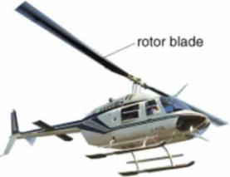**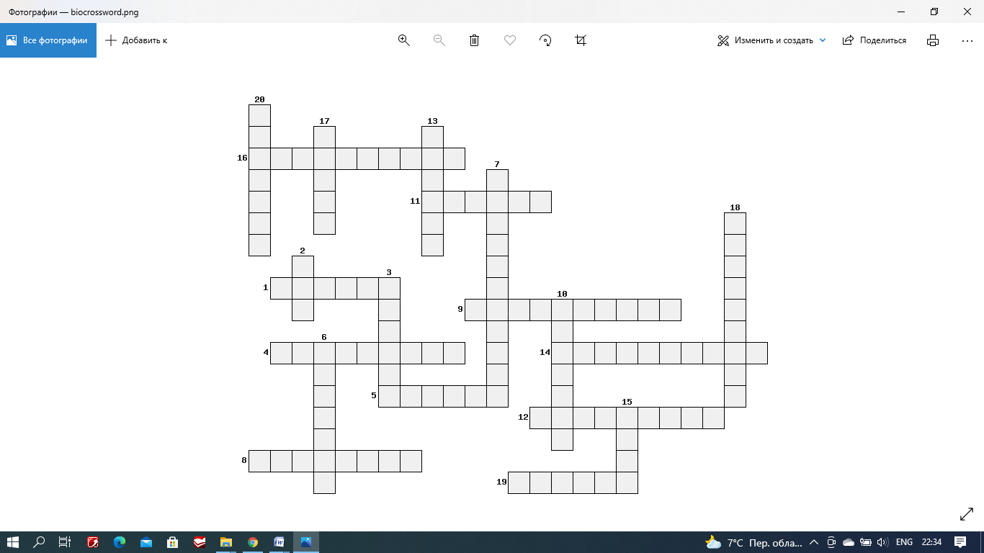**

**Across**

1. a ship or a large boat;

4. someone who is travelling in a vehicle, plane, boat etc;

5. how tall someone or something is;

8. the natural force that prevents one surface from sliding easily over another surface;

9. a type of aircraft with large metal blades on top;

11. a light plane that flies without an engine;

12. a very important event in the development of something;

14. the natural ability that makes a machine or person able to do something;

16. cheap enough for most people to afford (providing something or allowing something to happen).

**Down**

2. a fast plane with a reaction engine;

3. to start something, usually something big or important;

6. the top layer of an area of water or land;

7. progress or development in your job, level of knowledge etc;

10. the area in a plane where the pilot sits;

13. a journey in a plane or space vehicle;

15. to turn around and around very quickly, or to make something do this;

17. to get on a bus, plane, train etc in order to travel somewhere;

18. at the present time;

19. process of making a drawing of something to show how you will make it;

20. a part of something that you notice because it seems important, interesting, or typical.

**GRAMMAR**

**6*. Rewrite the following sentences starting with the words given in brackets. Translate them into Russian.***

1. Industrial countries are trying to find an alternative power source.(It is high time …)

2. A new experimental nuclear fusion reactor is to be built. (They suggested that…)

3. The use of light provides new ways of storing and processing information.(It is desirable …)

4. The robot that can make a copy of itself is created. (I wish…)

5. Self-replicating machines will revolutionize robotics when they appear. (If… they…)

6. These days robots perform a wide range of surgeries. (It is desirable that in the future…)

7. More and more technology shows up in operating rooms every day. (It is high time …)

8. Robotic surgery will speed recovery time of patients and decrease complications and discomfort. (Medical scientists predict…)

9. Stem cells will be used to begin a novel therapy for heart failure. (If only…)

10. Governments are making progress towards lessening the effects of climate change. (I wish…)

11. New jets will fly up to 17,000 miles per hour when technological problems are solved. (If… they…)

12. Computer components get smaller and smaller over time and eventually will get down to the atomic scale. (Feynman suggested that, as…)

**7*. Read the information in the box then match each statement (1-10) below with either of speakers Tanya or Mike.***

*Tanya has got a car, but she has failed her driving exam.*

*Mike has got a driving license and experience in driving, but he borrows a car from his friend Tanya.*

1. I wish I had a driving license.
2. Supposing I didn’t have a driving license.
3. It’s high time I got a driving license.
4. If only it hadn’t taken so much time to take driving lessons. And still I haven’t passed.
5. Suppose I hadn’t driven the car all those years.
6. I’d rather I had my own car.
7. Sometimes I feel as it were my own car.
8. What if I never had a car.
9. If only my brother wouldn’t use my car.
10. I wish I hadn’t sold my car.
11. If only I could afford to pass this exam.

**8*. Paraphrase the following sentences using would/wouldn’t. Make some of them more polite. Use the words appreciate, mind, consider.***

1. I will be grateful to you for your help.

2. Can you answer a few questions?

3. I won’ agree to change career.

**MODULE 8 PROGRESS TEST**

**Vocabulary**

***Decide which answer a, b or c best fits into each gap.***

**A radical idea** is being explored at Delft University of Technology in the Netherlands. Researchers there are working on a new aircraft 1.\_\_\_\_\_\_\_ known as the "Flying-V". It is a new concept for a 2.\_\_\_\_\_\_\_\_ aircraft, which they claim would be up to 20% more 3.\_\_\_\_\_\_\_than state-of-the-art modern planes. They suggest abandoning the idea of a 4.\_\_\_\_\_\_\_fuselage. But in this case the shape is more like an arrowhead, with two wings stretching out behind the 5.\_\_\_\_\_\_\_in a V. Passengers and cargo would be carried within the wings themselves. The designers think it would be cheaper to build than the blended 6.\_\_\_\_\_\_\_ because the two arms of the V could be "plugged" into the rest of the fuselage. So the aircraft could be built in parts, 7. \_\_\_\_\_\_\_\_all at once. The design takes8.\_\_\_\_\_\_\_\_\_ from the ideas of a graduate student which formed part of his thesis. It is being developed with 9.\_\_\_\_\_\_\_ from the Dutch airline KLM and Airbus - and in July a scale model took to the skies for the first time.The flight of the test aircraft was deemed a 10.\_\_\_\_\_\_\_\_.

1. a. design b. pattern c. outline

2. a. distant b. long duration c. long-haul

3. a. effluent b. effective c. efficient

4. a. convenient b. conventional c. constructive

5. a. pilot zone b. cockpit c. cabin

5. a. domination b. power c. authority

6. a. wave b. wind c. wing

7. a. rather b. rather than c. instead

8. a. inspiration b. creativity c. illumination

9. a. maintenance b. support c. assist

10. a. succeed b. succession c. success

**Grammar**

1. It is essential that cosmic ray \_\_\_\_\_\_\_\_\_\_\_\_ referred as high-energy radiation particles.

a. should have been b. should c. should be

2. A team of structural engineers at Airbus suggested some ideas \_\_\_\_\_\_\_\_\_\_\_\_ about how we may reduce the damage aircraft cause to the ozone layer.

a. be proposed b. proposed c. to propose

3. It has enormous power of brain to create such transportation system in the world in which people \_\_\_\_\_\_\_\_\_\_\_\_ wherever they want without any limitations.

a. would travel b. would have travelled c. travelled

4. New supersonic commercial flight would surely create unnecessary noise. I’d rather \_\_\_\_\_\_\_\_\_\_\_\_.

a. they wouldn’t b. they didn’t c. they hadn’t

5. Even if a flight \_\_\_\_\_\_\_\_\_\_\_\_ profitable for an airline, the airline couldn't afford of jets.

a. will be b. would be c. were

6. He always talks as though he \_\_\_\_\_\_\_\_\_\_\_\_ everywhere.

a. had travelled b. travelled c. would travel

7. If you \_\_\_\_\_\_\_\_\_\_\_\_ the boat up, it wouldn't have drifted away.

a. had tied b. tied c. tie

8. It is essential that the aircraft waiting to take-off \_\_\_\_\_\_\_\_\_\_\_\_ on the apron, ready to enter the runway.

a. be held b. should held c. hold

9. It’s about time you \_\_\_\_\_\_\_\_\_\_\_\_ to write grammatically correctly.

a. have started b. started c. start

10. A journey that \_\_\_\_\_\_\_\_\_\_\_\_ the Titanic 137 hours took only 3.5 hours for supersonic aircraft.

a. would have taken b. would take c. will take